Sandy Chau

Ouput for IterativeMergeSort with input 29:

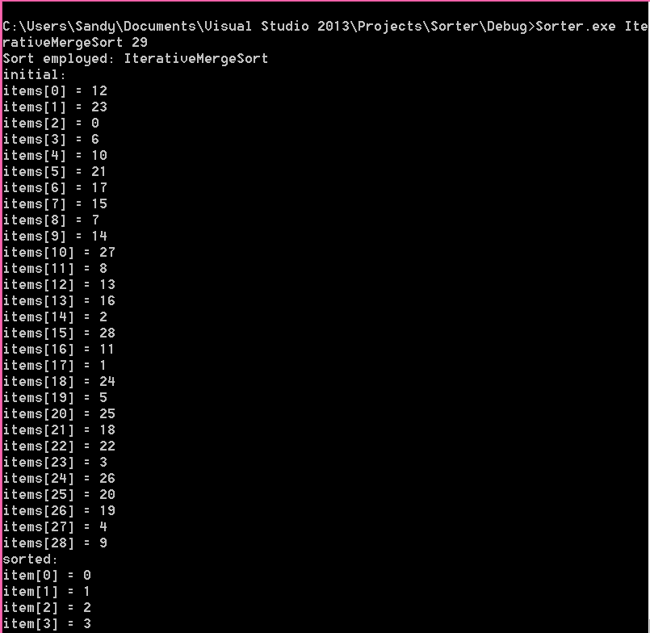

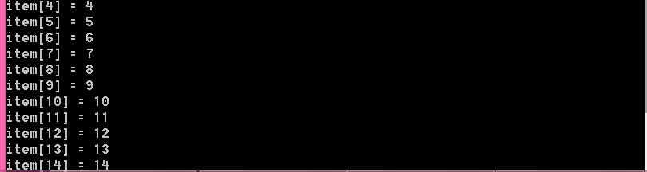

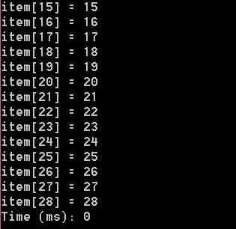

//Helper Function that is used by both Merges

void MergeHelper(vector<int> &items, int start, int mid, int end)

{

//Creates a temp vector

vector<int> tempInts(end + 1);

int start1 = start;

int end1 = mid;

int start2 = mid + 1;

int end2 = end;

int index = start1;

while ((start1 <= end1) && (start2 <= end2) && (index <= end))

{

if (items[start1] < items[start2])

{

tempInts[index] = items[start1];

start1++;

}

else

{

tempInts[index] = items[start2];

start2++;

}

index++;

}

while ((start1 <= end1) && (index <= end) && (start1 <= end))

{

tempInts[index] = items[start1];

start1++;

index++;

}

while ((start2 <= end2) && (start2 <= end) && (index <= end))

{

tempInts[index] = items[start2];

start2++;

index++;

}

//Copies temp vector back to the original

for (index = start; index <= end; index++)

{

items[index] = tempInts[index];

}

}

